Finding and Eliminating Photo Duplicates — Safely

This article presents a practical, safe approach to finding and eliminating duplicate photos — even when filenames, formats, and resolutions differ. Full source code available for download.

Digital duplicates
If you’ve been collecting photos for years, across phones, cameras, laptops, and cloud backups, chances are your library contains far more images than you realize — and many of them are duplicates.

Not only obvious duplicates with the same filename, but subtle ones: the same photo saved at different resolutions, exports from editing apps, copies created during backups or device migrations and recompressed versions from messaging apps. Manually cleaning this up is tedious and risky. Delete the wrong file and you lose the best version forever.

The goal of this project is simple: identify duplicate photos accurately, decide which version is best, and remove the rest — without guesswork or blind deletion.

To eliminate duplicates safely, we first need a reliable way to answer a deceptively simple question: Do these two images represent the same photo? Comparing files directly doesn’t work. Filenames change. Sizes change. Compression changes. Even metadata can make identical photos appear different at the file level. This is where hashing comes in.

How we recognize the same photo
To detect digital duplicates—both identical and visually similar photos—we use a technique called hashing. The term hash originates from old Dutch and English words meaning to chop and mix food, often leftovers, into a stew.

In computer science, hashing follows a similar idea: data is ‘chopped up and mixed together’ and transformed into a fixed-size value. Formally, hashing converts input data of arbitrary size into a fixed-length representation, known as a hash value or digital fingerprint, using a mathematical algorithm.

Hashing is widely used in cybersecurity to ensure data integrity. It also enables fast lookup and indexing—critical for databases and search engines.

Recognizing photos without looking at every pixel
Above, I described hashing as taking a fingerprint of an image. Not a fingerprint that identifies who is in the photo, but one that captures what the image looks like in a very compact form.

A hash is a short numerical summary of a file. Instead of comparing two full images pixel by pixel—which is slow and fragile—we compare their hashes. If the hashes are very similar, the images are probably the same, or at least look the same.

Think of it like this. An image may be 5–10 MB, a hash may be 8 bytes. Comparing two hashes takes microseconds. Hashing turns a visual problem into a fast comparison problem.

Why use hashing to find duplicate images?
Because duplicate rarely means bit-for-bit identical in real photo collections. Two photos can be: resized, recompressed, slightly cropped, rotated by camera metadata, exported from different apps … and still be visually the same photo.

Traditional file comparison fails here. Hashing succeeds because it answers a better question: do these two images look the same to a human? Rather than: Are these two files exactly identical?

Same file vs. same picture
Exact hashing focuses on file identity. This is the classic kind of hashing where every single byte matters. Change one pixel —and the hash changes completely. Exact hashing is excellent for finding perfect copies, detecting corrupted files and verifying downloads. It is, however, poor at finding resized or recompressed photos. In photo collections, exact hashing alone usually finds only a small fraction of duplicates.

Perceptual hashing focuses on visual similarity. Perceptual hashing works differently.
Instead of hashing the raw file, it creates a simplified version of the image, extracts visual structure (edges, shapes, contrast, color patterns) and encodes that structure into a compact fingerprint. Small visual changes now cause only small hash differences. This allows similarity, not just equality.

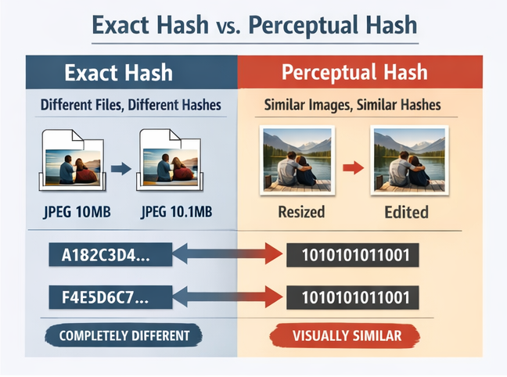
Figure 1: Same file vs. same picture: exact hashing detects byte-identical files, perceptual hashing detects visually identical images.

Why compare hashes by distance?
Perceptual hashes are not compared as equal / not equal. Instead, they are compared by how many bits differ. This allows fuzzy matching instead of brittle yes/no decisions.

Similarity is typically measured using the Hamming distance, the number of differing bits between two hashes. A smaller distance indicates greater visual similarity. For example, the distance between 0101 and 1111 is 2—two bits differ.

Limitations
As every technique, also our hashing approach has its limitations:
- Very heavy crops may no longer be considered duplicates.
- Strong artistic filters can break perceptual similarity.
- Extremely low-quality thumbnails may lack enough structure.
These cases are treated conservatively to avoid accidental data loss.

Why not use deep learning?
Deep vision models are powerful but slower, harder to explain, and harder to audit. For duplicate detection, perceptual hashing offers speed, transparency, and deterministic behavior — all essential when deciding which files to delete.
What this tool actually does
At a high level, the duplicate finder performs four steps:
- Scan your photo collection.
Each image is analyzed without modifying the original files.
- Identify duplicates and near-duplicates.
Both perfect copies and visually identical images are detected.
- Group related images together.
All copies of the same photo are clustered into one group.
- Recommend which file to keep.
The highest-quality version is selected automatically.
Nothing is deleted by default. All decisions are reviewable.

Finding and eliminating duplicates
To efficiently scan a collection of, say 50,000 images and weed out the low-quality copies, you need an algorithm that is both fast and robust. You can’t rely on a single hash or a single pass. Instead, we use a two-pass strategy.

Two-pass duplicate detection
We’ll use two passes. First an exact hashing pass (using SHA1) that is fast and decisive and catches byte-identical files even if filenames differ. That means it will detect: same image copied to another folder, same image renamed, same image duplicated by backup tools …but it will not match recompressed or resized variants.

That’s perceptual hashing’s job. So a second, perceptual hash pass is needed to catch visually identical or near-identical images (resized, recompressed, etc.). Next we’ll look into the techniques that are used to this end.

Finding photos that look the same
A perceptual hash typically follows this pattern. First, normalize the image, rotate it correctly (using camera metadata) and resize it to a small, fixed size. This ensures all images are treated equally. Second simplify the image, for instance convert to grayscale, reduce noise, and fine detail. Third, extract visual structure: edges, shapes, repeating patterns or coarse color balance. Fourth, encode that structure into a compact binary pattern. Similar images will produce similar patterns.

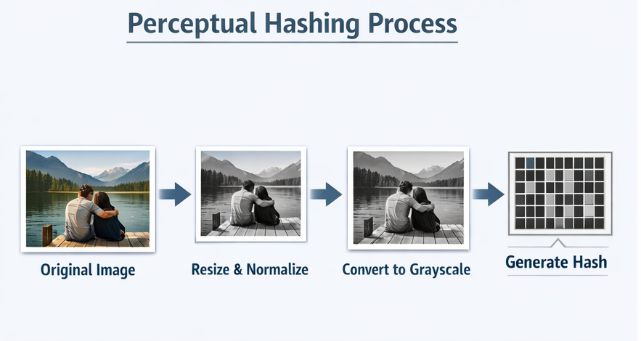
Figure 2 Perceptual hashing pipeline: images are normalized, simplified, and reduced to structural fingerprints.

Why use multiple perceptual hashes?
Our script uses multiple perceptual hashes because no single ‘view’ of an image is perfect. Different perceptual hashes focus on different visual aspects—much like human vision does. Using more than one hash is like asking multiple witnesses the same question.

The main perceptual hash types
dHash - Focus on outline & geometry. Captures brightness changes between neighboring pixels. Extremely fast and effective for resized or recompressed images.

pHash – Focus on overall shape & composition. Looks at low-frequency patterns and ignores fine detail. Robust against noise and small edits.

wHash – Focus on texture & rhythm. Looks at wavelets to capture structure at multiple scales. Complements pHash and dHash. Excellent for resolving borderline cases.

colorhash – Focus on color palette. Captures coarse color distribution. Useful as a secondary signal when structure alone is ambiguous.

Together, this ensemble keeps false positives low without sacrificing speed.
Below is a simplified excerpt showing how perceptual hashes are computed per image

# --- hashing ---
def _hash_one(self, path: str) -> Optional[Features]:
try:
im = make_thumb(path, self.cfg.max_side, self.cfg.animated_webp_policy)
except _SkipImage:
self.log(f"skip animated webp: {path}")
return None
except Exception:
return None
try:
w, h = im.size
hs = self.cfg.hash_size
dh = int(str(imagehash.dhash(im, hash_size=hs)), 16)
ph = int(str(imagehash.phash(im, hash_size=hs)), 16)
wh = int(str(imagehash.whash(im, hash_size=hs)), 16)
ch = int(str(imagehash.colorhash(im, binbits=3)), 16) if self.cfg.use_colorhash else 0
size = os.path.getsize(path)
# Sharpness from PIL image to avoid cv2 imdecode issues on animated formats
sharp = 0.0
if _HAS_CV2:
try:
g = np.array(im.convert("L"), dtype=np.uint8)
sharp = float(cv2.Laplacian(g, cv2.CV_64F).var())
except Exception:
sharp = 0.0
exact = sha1_file(path) if self.cfg.do_exact_hash else ""
return Features(path, w, h, dh, ph, wh, ch, size, sharp, exact)
except Exception:
return None

Why this approach scales to large collections
Hashing enables three crucial things. Speed, millions of comparisons become feasible. Memory efficiency, you compare fingerprints, not images. Clustering, group families of duplicates instead of only pairs. This makes it suitable for personal photo archives but also professional media libraries.

Hashing and clustering form the engine that powers duplicate detection.

Grouping all copies of the same photo
If image A is similar to B, and B is similar to C, do A, B, and C belong together? Clustering answers this question. We use Union–Find (disjoint-set) clustering, which groups images into connected components. If: A ≈ B, B ≈ C then A, B, C form one cluster even if A was never directly compared to C.

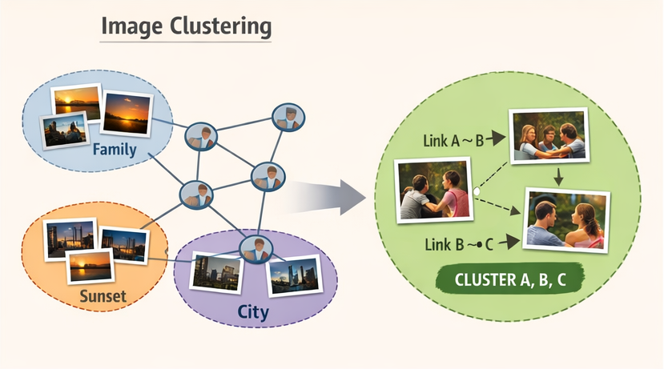
Figure 3 Clustering via transitive similarity: if A ≈ B and B ≈ C, all belong to the same group.

Bucketed clustering performance optimization
We reduce comparisons by grouping images into buckets using a coarse hash prefix and only comparing images within the same bucket. This can reduce comparisons from millions to thousands without sacrificing correctness.

Similarity decision: conservative + corroboration
Similarity is determined in stages. dHash first, if Hamming(dHash) ≤ threshold, accept. For the borderline zone: If dHash is close but not decisive, require agreement from pHash and wHash. This corroboration strategy significantly reduces false positives.

if dhash_dist <= T1:
similar
elif dhash_dist <= T2 and phash_dist <= T3 and whash_dist <= T4:
similar
else:
different

Keeper policy - Which file do we keep?
From each cluster, we deterministically select one keeper based on multi-criteria ranking. We prefer files based on:
- Max resolution – keep the best source material.
- Sharpness (Laplacian variance).
- File format preference, we prefer RAW/TIFF over PNG over JPEG, etc.
- Bytes per pixel as a proxy for compression quality.
- File size as the final tie-break.
This is practical: tools that don’t pick a keeper create messy manual workflows.

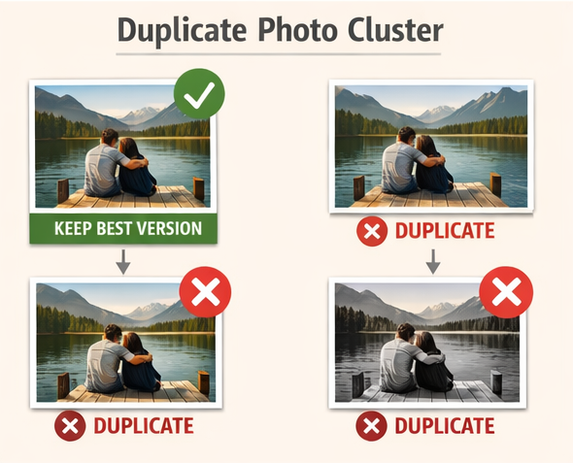
Figure 4 Duplicate photo cluster: multiple versions of the same photo grouped together, with one high-quality keeper selected automatically.

Why this approach is safe
We use several built in safeguards:
- Original files are never modified.
- Deletion is optional and reversible.
- Decisions are based on multiple independent signals.
- Results are auditable via CSV reports.
The system is designed to reduce risk, not maximize aggression.

Duplicate detection isn’t about clever algorithms — it’s about confidence.
Confidence that you’re keeping the best version of your photos. Confidence that nothing valuable is lost. Confidence that a messy archive can be cleaned up safely.
Hashing, clustering, and scoring are simply the tools that make that confidence possible.

Safe execution: dry-run, quarantine and audit CSV
Nothing is deleted blindly. Default behavior is dry-run. Files marked for removal can be moved to a quarantine directory. Every run produces a CSV report with the keep/drop decisions (recommendations), so you stay in control.

Dual-mode integration (CLI and GUI PyQt)
The script is structured so the same engine runs as a command line tool and also as a PyQt6 worker inside a GUI application. One engine, multiple front-ends — a key architectural goal of the Person Recognition project.

LinkedIn version

This article presents a practical, safe approach to finding and eliminating duplicate photos — even when filenames, formats, and resolutions differ.

Finding & Eliminating Photo Duplicates — Safely

The typical collection
If you’ve collected photos for years across phones, cameras, laptops, and cloud backups… there’s a high chance your library contains far more images than you think.

And many of them are duplicates. Not just obvious ones with the same filename. Subtle ones also. The same photo in different resolutions, recompressed versions from messaging apps, exports from editing tools, copies created during migrations or backups.

Cleaning this up manually is slow and risky. Delete the wrong file and you might lose the highest-quality version forever.

The goal
Build a system that can identify duplicate and near-duplicate photos, group them correctly and automatically select the best version. While never deleting anything blindly.

The key idea: Same file vs. same picture
There’s a crucial difference between the same file (byte-identical) and the same picture (visually identical). So the solution uses a two-pass strategy.

Exact hashing (SHA-1). Catches perfect copies — even if renamed or moved.

Perceptual hashing. Catches resized, recompressed, or lightly edited versions that look the same.
Instead of comparing full images pixel-by-pixel, we compare compact fingerprints (hashes). Small visual changes produces small hash differences. This makes scanning tens of thousands of photos feasible.

From pairs to groups
If A looks like B and B looks like C, then A, B, and C belong together. Using a Union–Find clustering strategy, the system groups all related versions into one cluster. From there, a deterministic “keeper policy” selects the best file based on resolution, sharpness, file format preference and compression quality proxy.

Safety first
Nothing is deleted by default. A dry-run mode and quarantine option are available. A full CSV audit trail is enabled standard. With multiple independent similarity checks, the system is designed to reduce risk — not maximize aggression.

Why not deep learning?
Deep vision models are powerful, but for duplicate detection they’re both slower and harder to audit and harder to explain. Perceptual hashing on the other hand provides speed, deterministic behavior and transparency. Which matters when you’re deciding what to delete.

The real outcome
Duplicate detection isn’t about clever algorithms. It’s about confidence. Confidence that
you’re keeping the best version, you’re not losing something valuable. Your archive becomes cleaner — safely.
Hashing and clustering are just the engine under the hood.

Full Article
If you're interested in the technical details (hash ensembles, bucketed clustering, corroboration thresholds, etc.), I wrote a deeper breakdown here at code2trade.dev.
👉 https://code2trade.dev/finding-and-eliminating-photo-duplicates-safely/

Download
Here you can download the full source code in Python.

The script is structured so the same engine runs smoothly as a command line tool and as a PyQt6 worker inside a GUI application. One engine, multiple front-ends — a key architectural goal of the Person Recognition project.

Reddit Version

Title (r/Python)
I built a duplicate photo detector that safely cleans 50k+ images using perceptual hashing & clustering

Post
Over the years my photo archive exploded (multiple devices, exports, backups, messaging apps, etc.). I ended up with thousands of subtle duplicates — not just identical files, but resized/recompressed variants.

Manual cleanup is risky and painful. So I built a tool that:
- Uses SHA-1 to catch byte-identical files
- Uses multiple perceptual hashes (dHash, pHash, wHash, optional colorhash)
- Applies corroboration thresholds to reduce false positives
- Uses Union–Find clustering to group duplicate “families”
- Deterministically selects the highest-quality version
- Never deletes blindly (dry-run + quarantine + CSV audit)

Some implementation decisions I found interesting:
- Bucketed clustering using hash prefixes to reduce comparisons
- Borderline similarity requires multi-hash agreement
- Exact and perceptual passes feed into the same DSU
- OpenCV Laplacian variance for sharpness ranking
- Designed to be explainable instead of ML-black-box

Performance:
- ~4,800 images → ~60 seconds hashing (CPU only)
- Clustering ~2,000 buckets
- Resulted in 23 duplicate clusters in a test run
Curious if anyone here has taken a different approach (e.g. ANN, FAISS, deep embeddings) and what tradeoffs you found worth it.

REDDIT DISCUSSION

https://www.reddit.com/r/Python/comments/1r73nrb/comment/o5um36q/

This is a sensitive but technically understandable idea. The short answer is:
Yes — cross-agency image matching systems already exist in that domain, and they go far beyond perceptual hashing. Law enforcement does not rely on ad-hoc perceptual hashing for CSAM detection. Entities like Interpol operate centralized or federated hash databases that law enforcement and platforms can query. hey typically use PhotoDNA, developed by Microsoft in collaboration with Dartmouth.
PhotoDNA is not standard pHash/dHash. It uses:
- Grayscale normalization
- Block-based DCT
- Robust transformation
- Very strong collision resistance
- Designed specifically for known-illegal content identification
Importantly:
It is optimized to match exact underlying content even if:
- Resized
- Cropped slightly
- Recompressed
- Color adjusted
And it is engineered to avoid false positives at very large scale.

Wow, 446,871 photos that is a huge collection. Runtime will vary a lot with hardware and even more with storage speed and where the files live (local SSD vs HDD vs NAS/network share).
In my script, total time is dominated by stage 1: hashing, because each file is opened/decoded, EXIF-transposed, thumbnailed, then hashed (dHash/pHash/wHash + optional colorhash) and optionally sharpness. That’s a mix of I/O + CPU decode.

Best practical way to estimate: run a fixed benchmark a sample and extrapolate. Run on a known subset of 10,000 images, record total hashing time and multiply by 44.6871. That gives a rather accurate forecast because the workload is mostly linear.

Succes!

Thanks!
Totally relate to the ‘lost control of originals’ fear. That’s exactly why I designed this to be non-destructive by default. A few clarifications on my side:
No thumbnails are written to disk. Thumbs are created in-memory only for hashing and then discarded. The script never replaces files with generated thumbs.
No deletions by default. It runs dry-run + produces a CSV audit, and the “delete” step is an explicit opt-in (I prefer quarantine / send-to-trash over hard delete).
Deterministic keeper policy. Within a duplicate cluster it picks a “keeper” based on resolution → sharpness → preferred format → compression proxy. The idea is: even if you do remove duplicates, you keep the best source material.

Your JSON registry approach is solid. I do something similar conceptually (feature table), and then:
Similarity search: BK-tree vs bucketing. BK-tree works nicely for Hamming distance (esp. for perceptual hashes). The tradeoff is it can get slow on very large N depending on query radius and distribution. I went with bucketing on hash prefixes + union-find clustering. It’s essentially “generate candidates cheaply” (reduce comparisons) and then merge via DSU so you get families/clusters instead of just nearest-neighbor pairs.

If you stick with BK-tree, one practical speed win is to use a coarse pre-filter first (e.g. first K bits bucket or aspect ratio bucket), then BK-tree inside the bucket. That keeps tree sizes smaller.

On ‘original control’. If you’re anxious about losing originals, two patterns help a lot. Quarantine instead of delete (move drops into a quarantine folder retaining paths/IDs). Persistent manifest/log (you already have JSON; add a reversible rename/move log so you can undo).

Also: +1 on comparing new imports against the registry — catching duplicates at ingest prevents the “300k spiral”.
And yeah, definitely share your GitHub when it’s up — I’d be interested to compare BK-tree behavior vs my bucket+DSU thresholds, especially on borderline cases (cropped/blurred/HEIC→JPG exports). Happy to link your repo in an update if you want.

Thanks — Fastdup is a great project and very capable at embedding-based similarity clustering!
My tool takes a more deterministic, perceptual-hash-centric approach focused on precise duplicate detection with explainability and safety. Fastdup’s embedding approach is complementary: it’s stronger at semantic/visual similarity across variation, whereas the hashing + clustering approach excels at exact/near duplicates with low false positives. They solve slightly different problems, and using them together (dedup first, semantic clustering second) can actually be a powerful pipeline.

That’s an impressive pipeline — embedding-based similarity & interactive UI is a powerful approach.
What you’re building is more of a semantic similarity explorer, whereas my script focuses on deterministic duplicate detection with low false positives and automated keeper selection.

Using DINOv3 + cosine similarity definitely increases recall across variation (especially for scanned images with slight crop/exposure differences), but at the cost of heavier compute and less deterministic grouping.
I really like the idea of persisting ‘not a match’ memory — that’s a very elegant human-in-the-loop refinement loop.

Your orientation trick also makes sense for scans where (my current) EXIF orientation isn’t reliable.
In a way, our approaches solve different layers: Perceptual hashing looking for precise structural duplicates vs deep embeddings looking for semantic similarity exploration.
They actually combine nicely — you could first prune exact/near duplicates cheaply, then run DINO embeddings on the reduced set for semantic clustering.
Would definitely be interested to see your repo once published!

Thanks — Czkawka is a great tool and definitely one of the better open-source options out there.
It’s very fast (Rust with multi-threading) and its similar-image mode uses perceptual hashing with configurable thresholds, which makes it quite effective for near-duplicate detection in large libraries.

My project is less about replacing existing GUI tools and more about exploring deterministic clustering behavior, explainable multi-hash corroboration logic, automated keeper ranking (resolution → sharpness → format → compression proxy) and CLI/automation integration and embedding into other pipelines.
Czkawka is excellent as a user-facing cleaner tool, I really admire it’s speed! Mine is more of an architectural exercise in controlled, explainable duplicate grouping. Definitely agree it’s worth studying — especially how they handle performance and threshold tuning in Rust.

Good point — HEIC↔JPEG is one of the trickier cases because the codec artifacts differ enough that perceptual hashes can drift more than expected (especially on foliage/texture).
In my current version they’re treated format-agnostically: load → EXIF transpose → thumbnail → multi-hash (dHash/pHash/wHash [+ colorhash]) with conservative thresholds + corroboration. Many HEIC/JPEG pairs still match, but some will miss if Hamming distances cross thresholds.

The next improvement I’m considering is a ‘format-crossing tolerance band’. If one file is HEIC and the other is JPEG, allow a slightly higher dHash distance only if pHash+wHash corroborate strongly (and optionally run SSIM on borderline pairs). That boosts recall for iOS export duplicates without loosening the whole system and increasing false positives. Proposing concrete threshold numbers for a HEIC/JPEG pass (safe defaults) would be difficult as the values depend on hash_size, thumbnail size, and whether you’re using ImageOps.exif_transpose().

A) Concrete improvements to the script suggested by the feedback

1) HEIC ↔ JPEG handling as a first-class scenario
You got a very specific, real-world pain point: iOS exports produce HEIC originals + JPEG derivatives where codec artifacts can push pHash/dHash distances higher than expected.
Improvement: add a format-crossing tolerance band:
- If one ext is .heic and the other is .jpg/.jpeg, allow slightly higher dHash distance only if pHash+wHash corroborate (and optionally colorhash).
This increases recall only in the scenario that needs it, without loosening the whole system.
(You can also make this a CLI flag: --heic-jpeg-relax so default behavior stays conservative.)

2) “Borderline safety” guardrail with SSIM or a cheap proxy
Multiple people mentioned trauma from aggressive pHash. Your corroboration already helps, but you can tighten safety further:
Improvement: optional SSIM check only when:
- dHash is in the borderline zone (e.g., thr < d <= thr+2) AND
- pHash+wHash are close enough to pass.
This makes false positives much rarer while keeping runtime reasonable (SSIM is applied to very few candidate pairs). This “borderline only” idea maps cleanly to your existing structure (you already have an SSIM hook in the code you posted).

3) Persistent registry + incremental runs (resume / ingest workflow)
Two independent commenters converged on the same concept:
- keep a JSON/SQLite registry
- compare new imports against it
- avoid reprocessing the whole archive
Improvement: add an “index mode”:
- --index out.sqlite stores features (hashes, dims, sharpness, size, mtime, maybe EXIF datetime)
- --scan --using out.sqlite --only-new processes deltas
This is huge for people with 50k→300k growth arcs.

4) Human-in-the-loop memory (“not a match”) for review workflows
The DINOv3 person built the best UX concept in the thread:
- mark “not a match”
- persist it
- don’t show again after rerun
Improvement: introduce a simple “pair blacklist” store:
- key = (sha1(pathA), sha1(pathB)) or stable content IDs
- consult it during clustering (or post-filter)
This turns your tool from a one-off cleanup into a curation system.

5) Burst-photo / wildlife mode (separate from dedup)
The focus/blur question indicates a demand for culling (best-of-burst) rather than dedup.
Improvement: define a second mode explicitly:
- Dedup Mode (current): strict similarity, low false positives
- Burst/Culling Mode: relaxed clustering + ranking focus metrics (sharpness, face/eye sharpness if you want later)
This is important not only technically but narratively: it prevents users from misusing dedup thresholds to do culling.

6) Hardware scaling improvements for 400k+ libraries
Someone ran ~446k images. That pushes you into operational features:
Improvements that matter at that scale
- checkpointing (write features as you go, don’t lose hours if interrupted)
- adaptive worker count (avoid I/O thrash on HDD/NAS)
- explicit “storage advice” in docs (“run on local SSD if possible”)

7) Explicitly document the tool boundary: “same picture” vs “same scene”
You saw deep-embedding people. You should preempt confusion.
Improvement: add a short doc section:
- what perceptual hashing is good at
- what it is not (semantic similarity / same subject different frame)
This prevents users from cranking thresholds into dangerous territory.

B) Best follow-up post angle: compare approaches without making it academic
The thread handed you a perfect sequel concept:
“Image Deduplication Is Not One Problem: Hashing vs Embeddings vs Hybrid Pipelines”

Why this will land:
- People already argued BK-tree vs bucketing, hashes vs embeddings, Czkawka/fastdup comparisons.
- You can tell a practical story: risk, speed, explainability, recall.

Recommended structure (high signal, not long)
1) Start with a taxonomy: 3 goals people confuse
- Exact duplicates (byte-identical)
- Near duplicates (same picture under resize/recompress/export)
- Similarity / curation (burst frames, same subject, same scene)
This instantly explains why different tools “feel” inconsistent.

2) Compare 4 approaches (each with “wins / fails / cost”)
- Perceptual hashes + Hamming (your approach; Czkawka/dupeGuru style)
- BK-tree over hash space (exact NN queries; tuning-free, but can still be heavy at scale)
- Embedding similarity (DINO/CLIP) + cosine + ANN (semantic power, higher compute; “culling-grade”)
- Hybrid: hash pass first → embeddings on reduced set (most pragmatic)
Tie in community tools:
- fastdup as “embedding-first dataset analysis”
- Czkawka as “fast GUI + perceptual hash mode”

3) The missing piece: evaluation and safety
Make this the “adult” part of the post:
- Without ground truth, false positives are the real enemy
- Present a simple evaluation protocol:
  - sample 200 predicted duplicate pairs
  - label true/false
  - tune thresholds to drive false positives near zero
- Explain why dry-run + quarantine + audit CSV is not optional.

4) Close with a roadmap
Use the Reddit feedback as a “v2 blueprint”:
- HEIC↔JPEG pass
- borderline SSIM
- registry/incremental scans
- review memory (“not a match”)
- optional embedding mode as a separate tool layer

The “most promising” positioning
If you have to pick one “future-proof” direction:
Hybrid pipeline is the most promising:
- Hashing = cheap, explainable, great at obvious near-duplicates
- Embeddings = expensive, powerful, great at curation/same-subject grouping
- Combine them to keep costs and risk sane

This aligns with what practitioners do in data-centric tooling: fast coarse pass → expensive refinement pass (fastdup even positions itself as dataset QA / similarity tooling at scale).

